BansilalRamnathAgarwalCharitableTrust’s

VishwakarmaInstituteofTechnology, Pune-37
(AnautonomousInstituteofSavitribaiPhulePuneUniversity)


Department of Multidisciplinary Engineering

Division | AIML-A
Batch | B2
GR-no | 12414334
Rollno | 49
Name | Bhagat Rishikesh Vijay

- Assignment No. 10
- Title - Hierarchical Agglomerative
- Theory
Hierarchical Agglomerative Clustering (HAC) in Machine Learning
1. Introduction
Hierarchical Agglomerative Clustering (HAC) is an unsupervised machine learning algorithm used to group similar data points into clusters. It follows a bottom-up approach, in which every data point initially forms its own cluster, and the closest clusters are progressively merged until the desired clustering structure is obtained.
Unlike K-Means, HAC does not require the number of clusters to be specified when constructing the complete hierarchy. A dendrogram can be used to determine an appropriate number of clusters.
2. Working of Hierarchical Agglomerative Clustering
The algorithm follows these steps:
- Initialize clusters: Treat each data point as an individual cluster.
- Calculate distances: Measure the distances between data points or clusters using a selected distance metric.
- Merge the closest clusters: Identify and combine the two clusters that are closest according to the chosen linkage method.
- Update cluster distances: Recalculate the distances between the newly formed cluster and the remaining clusters.
- Repeat the process: Continue merging clusters until only one cluster remains or the required stopping condition is reached.
- Determine the final clusters: Use a dendrogram or a predefined number of clusters to select the final grouping.
3. Important Concepts and Formulas
A. Euclidean Distance
Euclidean distance measures the straight-line distance between two data points in a feature space.
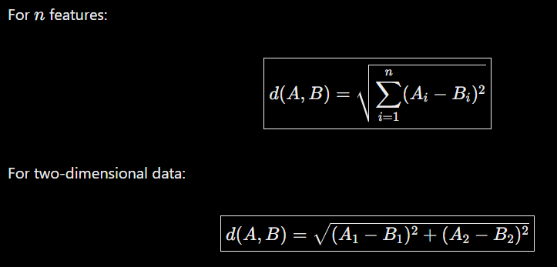
Where:
- (A_i) and (B_i) represent the feature values of points (A) and (B).
- (n) is the number of features.
- (d(A,B)) is the distance between the two points.
B. Linkage Methods
A linkage method determines how the distance between two clusters is calculated.
Linkage method | Definition
Single linkage | Uses the minimum distance between any point in one cluster and any point in the other cluster.
Complete linkage | Uses the maximum distance between any point in one cluster and any point in the other cluster.
Average linkage | Calculates the average distance between all pairs of points across the two clusters.
Ward linkage | Merges clusters that produce the smallest increase in within-cluster sum of squared deviations.
For clusters (A) and (B), the formulas are:
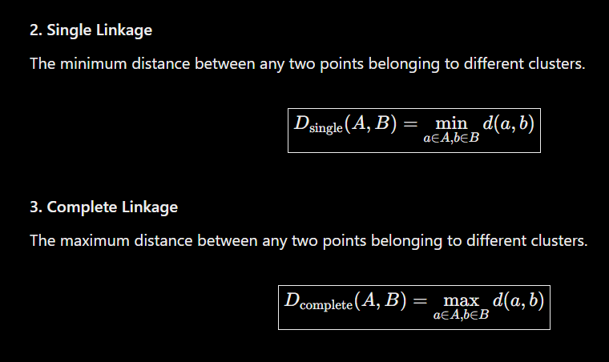
Average linkage
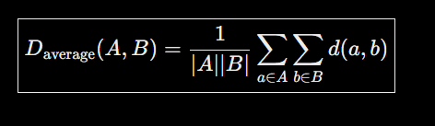
Ward linkage selects the merge that minimizes the increase in within-cluster sum of squares.
C. Dendrogram
A dendrogram is a tree-shaped diagram that illustrates how clusters are merged at different distances.
It helps visualize the hierarchical relationships among data points and identify a suitable number of clusters.
To determine the number of clusters, draw a horizontal line across the dendrogram. The number of separate branches intersected by that line indicates the number of clusters formed at that cut height.
D. Cluster Distance
At each iteration, HAC identifies the pair of clusters with the smallest linkage distance and merges them.
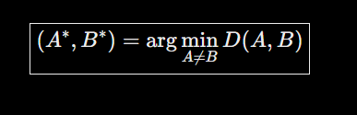
Where:
- (A^) and (B^) are the clusters selected for merging.
- (D(A,B)) is the distance between clusters according to the chosen linkage method.
4. Advantages and Disadvantages
Advantages
- No centroid initialization: The algorithm does not require randomly initialized centroids.
- Visual interpretation: Dendrograms help illustrate cluster relationships and merging distances.
- Nested cluster structure: It can reveal groups at different levels of similarity.
- Flexible cluster selection: The number of clusters can be selected after constructing the hierarchy.
- Multiple linkage options: Different linkage methods allow different definitions of cluster similarity.
Disadvantages
- High computational cost: It can be expensive in terms of time and memory for large datasets.
- Irreversible merges: Once two clusters are merged, the standard algorithm does not undo that decision.
- Sensitivity to linkage choice: Different linkage methods can produce different cluster structures.
- Sensitivity to outliers: Extreme data points can influence distances and merging decisions.
- Feature scaling requirements: Features with larger numerical ranges may dominate distance calculations, so scaling is often necessary.
5. Applications of Hierarchical Agglomerative Clustering
HAC is used in several real-world applications:
- Customer Segmentation: Groups customers according to purchasing habits and preferences.
- Document Clustering: Organizes documents based on textual similarity or numerical representations.
- Biological Classification: Groups organisms according to similarities in their characteristics.
- Gene Expression Analysis: Identifies groups of genes with similar expression patterns.
- Product Analysis: Groups similar products based on their features.
- User Behavior Analysis: Identifies groups of users with similar activity patterns.
6. Conclusion
Hierarchical Agglomerative Clustering is an unsupervised learning algorithm that builds a hierarchy of clusters by repeatedly merging the closest groups. Its bottom-up approach and dendrogram visualization make it useful for understanding relationships and nested structures in data.
The algorithm supports different linkage methods, including single, complete, average, and Ward linkage. Although it can be computationally expensive for large datasets and is sensitive to distance and linkage choices, HAC remains a valuable technique for exploratory data analysis, customer segmentation, biological research, and document grouping.

